Magnetic Force versus Distance

Magnetic Field Strength, B

Imagine a very thin and very long bar magnet, so long that only a North pole is in view. As shown in the diagram, the magnetic field lines spread out from the North pole and cross a sphere. Recall that when the field lines are close together the magnetic field B is strong and when they are far apart, then the magnetic field B is weak. We can measure this by counting how many field lines cross the area of a sphere as it grows and shrinks. The number of field lines crossing the sphere is a constant even though the sphere is getting bigger and smaller. When the radius of the sphere is small then the area is small and there are many field lines in each square meter. When the radius is large the area is large and there are few field lines in each square meter. The magnetic field strength B is proportional to Number of Lines N divided by the sphere area, or

B ≈ N / Area = N / (π r²)

where r is the radius of the sphere. The radius is the distance from the North pole, so we write r=d giving

B ≈ 1 / d².

The magnetic field gets weaker with the square of the distance from a pole.

Force between Magnets

The force between two magnets is proportional to the strength of the magnetic fields of the magnets. However, every magnet comes with two poles. Whenever two magnets are close to each other, the two North poles repel each other, each North pole attracts the other South pole, and the two South poles repel. All these different attractions and repulsions cause some cancellations. This means that the total force F between the magnets doesn’t decrease as 1/d² but rather decreases with the cube of the distance, i.e.

F ≈ 1 / d³.

Let’s measure the how the force between two magnets varies with their distance .

Experiment: Magnetic Force versus Distance for magnets
There are two convenient ways to measure the strength of two magnets interacting as we change the distance between the magnets.

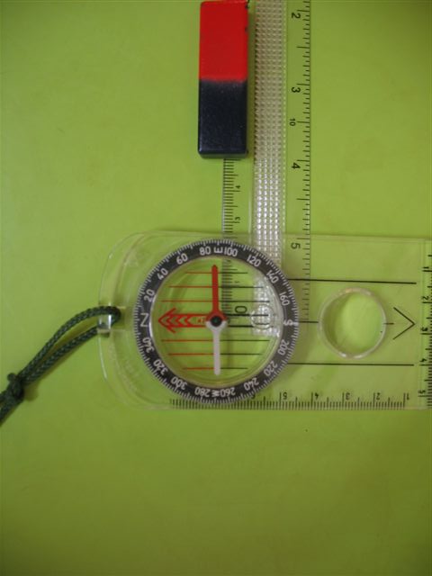
The first places a bar magnet a distance d due West or due East of a compass as shown in the figure.

If the bar magnet is a long way from the compass, the compass needle is undeflected and points to magnetic North. If the bar magnet is very close to the compass, the compass needle points directly to the bar magnet, in an East-West direction.

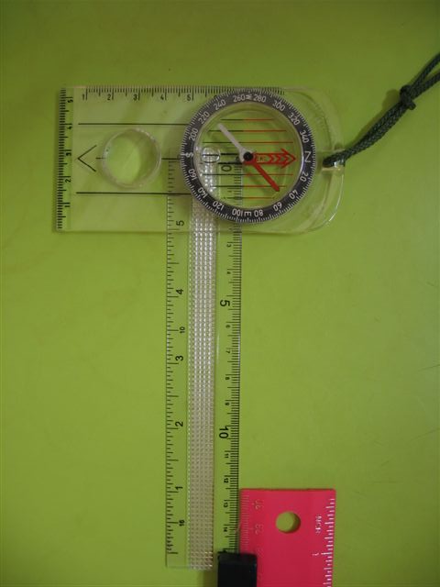
There are two forces acting on the compass needle. The force of the Earth’s magnetic field (North-South), and the force of the bar magnet (East-West). These forces are at right angles, and their respective magnitudes determine the angle of the compass needle. In fact, the ratio of the forces determines the tangent of the angle of deflection of the compass needle, so the tangent of the angle measures the force of the bar magnet.

That is, Force ≈ tan (θ), so a measurement of the angle gives the Force of the bar magnet on the compass needle.

The other convenient way to measure the strength of the force between two magnets is to attach one bar magnet to the metal dish of a digital scale, and then to raise and lower another bar magnet above it.

When the top magnet is a long way away, the scale reads only the mass of the bottom magnet in grams. When the top magnet is brought closer, the scale reading changes. The difference in the scale reading (in grams) is a measure of the force of the top magnet on the bottom magnet. If a ruler is also used to measure the separation of the magnets, then we can measure the Force and Distance relation.

Note the reading on the scale is proportional to the force between the bar magnets. The change in the scale reading (in grams) is equivalent to a change in the mass of the magnet which is proportional to the force as Force ≈ m g, and we ignore g.

Please choose one of these two methods to measure the Force and Distance relation between magnets.

Data

Please record your data in the table. (Example data is also shown and plotted below.)

Distance  (d, m) | θ, (compass) | tan (θ)  ≈ Force | Mass difference Scales (g)  ≈ Force | Example  Distance  (d, m) | Example  θ, (compass) | Example  tan (θ)  ≈ Force
 |  |  |  | 0.43 | 3 | 0.052408
 |  |  |  | 0.4 | 5 | 0.087489
 |  |  |  | 0.35 | 7 | 0.122785
 |  |  |  | 0.3 | 9 | 0.158384
 |  |  |  | 0.25 | 16 | 0.286745
 |  |  |  | 0.2 | 26 | 0.487733
 |  |  |  | 0.15 | 48 | 1.110613
 |  |  |  | 0.1 | 74 | 3.487414
 |  |  |  | 0.05 | 89 | 57.28996

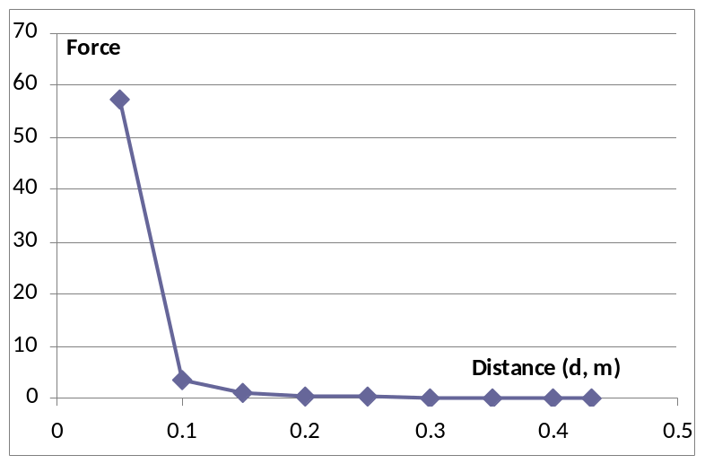
Add your own plot of “Force” versus Distance (in meters) to the graph at the left. (The example data is only a guide for your own work.)

Analysis

There are three common ways to prove that this line has the predicted shape (F ≈ 1 / d³.)

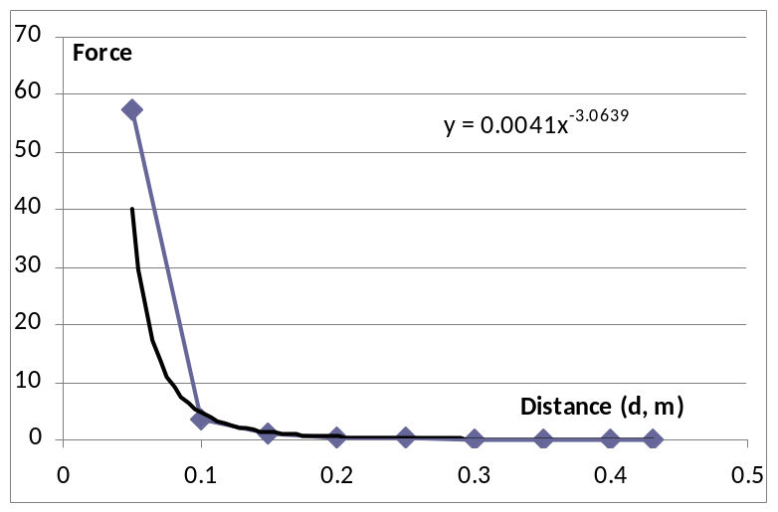
The first approach is to use a Power Law fit in Excel (or a graphics calculator). In Excel, add a trend line to a graph and choose a power law fit. Excel tries to fit the curve F = a d^{b} and provides values for a and b. The result is shown here.

Write the equation for the power law line of best bet for your own data. What power law index did you obtain for your data? Was it close to -3 as expected?

The second method simply uses the predicted relation F ≈ 1 / d³ to predict that a plot of new variables y = F versus x = 1 / d³ will give the equation y = x and so correspond to a straight line graph. Evaluate your data to plot this straight line. (Again, our example data is provided.)

Force, F | d (m) | 1 / d³ (m-3) | Force, F | d (m) | 1 / d³ (m-3)
 |  |  | 0.052408 | 0.43 | 12.57751
 |  |  | 0.087489 | 0.4 | 15.625
 |  |  | 0.122785 | 0.35 | 23.32362
 |  |  | 0.158384 | 0.3 | 37.03704
 |  |  | 0.286745 | 0.25 | 64
 |  |  | 0.487733 | 0.2 | 125
 |  |  | 1.110613 | 0.15 | 296.2963
 |  |  | 3.487414 | 0.1 | 1000
 |  |  | 57.28996 | 0.05 | 8000

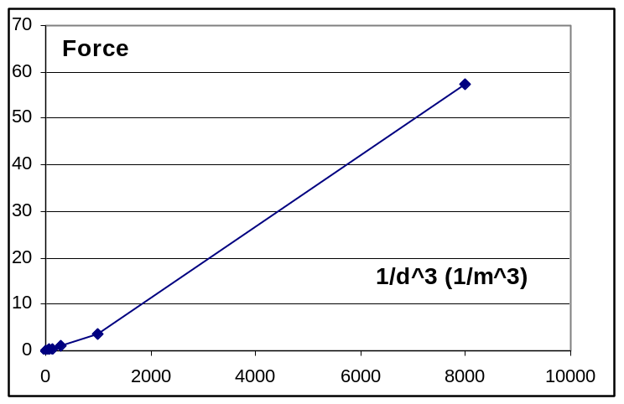
Add your own data to the graph at left. Does your data result in a straight line? The line will only be straight if your data shows that Force decreases as the cube of the distance.

The third method takes the log of both sides of the F ≈ 1 / d³ relation. This gives log(F) = -3 log(d) so a plot of log(F) versus log(d) should be a straight line of slope -3. See if your data does in fact give a straight line of slope -3.
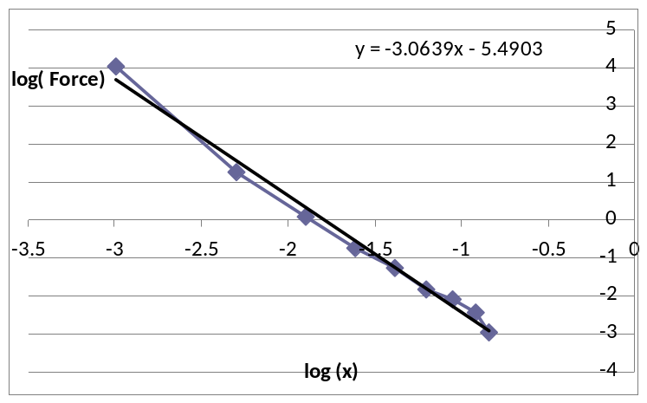
log(F) | log(d) | log(F) | log(d)
 |  | -2.9487 | -0.84397
 |  | -2.43625 | -0.91629
 |  | -2.09732 | -1.04982
 |  | -1.84273 | -1.20397
 |  | -1.24916 | -1.38629
 |  | -0.71799 | -1.60944
 |  | 0.104912 | -1.89712
 |  | 1.249161 | -2.30259
 |  | 4.048125 | -2.99573

Note that the chart shows a Trend Line with option to display the equation of the line of best fit on the graph. This does indeed show a slope of -3. (Note that this value is the same as derived using the first method.)

